**Docker**

1. **My first container created**

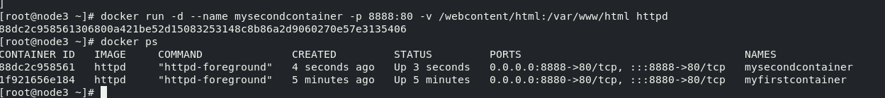

1. **My second container created**

**3. Login to the mysecondcontainer, and do the following**

File path: /var/www/html

Filename: index.html

Add the text: The Ip address of this container is <<IP-Address>>

Couldnt create ubi simple container login to redhat registry denied.



1. **SimpleContainer ran for 2 mins**



1. **DB container running**

**KUBECTL**

**Namespace = exkube**

c) Once the deployment is successfully created and the pod status is RUNNING, take a screenshot of the below command and paste below: kubectl get all -n exkube

3 replicas set

Exposing node port

2. Create a pod using the following specifications:

Name: random-logger-studentX : had to change the name to random-logger-studentx since it was giving errors

Create a nginx pod such that the pod always runs on node2

Name: nginx-studentX-pod

Namespace: mytcs

Node: node2

Provide screenshot of the command that shows nginx pod you created in previous Question is running in your cluster.

Create the Pod as per the following specifications:

Name: simple-pod-kube

Namespace: machinelearning

Maximum CPU: 750m

Maximum Memory: 500Mi